

Foundations of Programming

Assignment No.: 18
PROBLEM STATEMENT: Write a C program that accepts a string from the user and performs the following string operations: i) Calculate length of string ii) String reversal iii) Equality check of two strings iv) Check palindrome v) Check substring.

OBJECTIVE:

- To understand basic string operations in C.
- To learn how to manipulate strings using loops and functions.
- To perform comparison, reversal, and substring checking.
- To check whether a string is a palindrome.

THEORY:
In C programming, a string is a sequence of characters terminated by a null character ('\0'). Strings are commonly stored in character arrays. Various operations can be performed on strings such as calculating their length, reversing the characters, comparing two strings, checking whether a string is a palindrome, and finding a substring within another string. These operations can be implemented using loops and conditional statements or by using standard library functions from the string.h header file.
PLATFORM: Linux

INPUT: A string and another string for comparison and substring checking.

OUTPUT: Displays string length, reversed string, equality result, palindrome result, and substring check result.

SAMPLE INPUT:

Enter a string: madam
Enter another string for equality check: mad
#include <stdio.h>
#include <string.h>
void main (){
char str[50],str2[50],rev[50];
int i,len,flag=1;
printf("enter a string :");
scanf("%s",str);
len=strlen(str);
printf("%d\n",len);
for (i=0;i<len;i++){
rev[i]=str[len-i-1];
}
rev[i] = '\0';

printf("%s\n", rev);
printf("enter the second substring:");
scanf("%s",str2);
if(strcmp(str,str2)==0){
printf("they are equal\n");
}else{
printf("they are not equal");
}
if(strcmp(str, rev) == 0){
printf("Palindrome\n");
}else{
printf("Not Palindrome\n");
}

if(strstr(str, str2) != NULL){
printf("Substring found\n");
}else{
printf("Substring not found\n");
}
}

SAMPLE OUTPUT:
Length of string = 5
Reversed string = madam
The string is a Palindrome
Strings are not equal
Substring found in main string
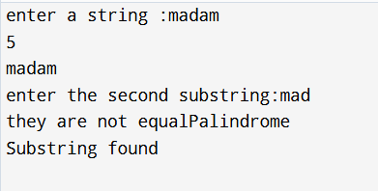

CONCLUSION: Thus, the C program successfully performs different string operations such as length calculation, reversal, equality check, palindrome check, and substring detection.

FAQs:
- What is a string in C programming?
- Which header file is required for string functions?
- What function is used to find the length of a string?
- What is a palindrome string?
- Which function is used to check a substring in C?

